|  |  |
| --- | --- |
|  | C:\Users\tazkiaabbas\AppData\Local\Microsoft\Windows\Temporary Internet Files\Content.Outlook\PVZE12X2\5th KLF LOGO_p2 (2).jpg\\PKKHI1BFP001\Home$\tazkiaabbas\Desktop\BCLT-logo-OP2-490x250.jpg |

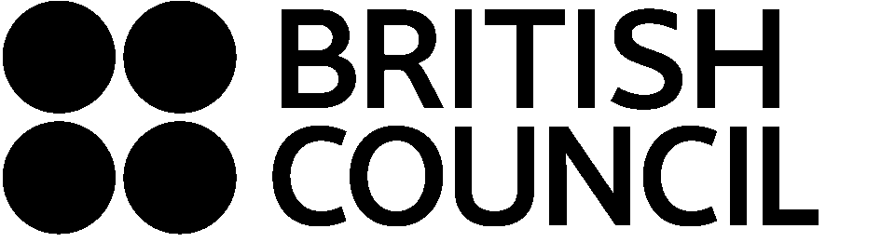

**Application Form for place on**

**Literary Translation Masterclass**

**5th and 6th February 2014**

**Karachi, Pakistan**

The literary translation masterclasses are an initiative of the British Council and the Karachi Literary Festival, in partnership with the British Centre for Literary Translation (BCLT). The literary translation masterclasses will bring together writers and translators for an intensive two days of consensus translation, based on the BCLT International Literary Translation Summer School, held at the University of East Anglia since 2000.

During the masterclasses the participants will work on a consensus translation into English of a short story by the Urdu writers in residence, led by an experienced literary translator, with the author present.

The masterclasses will be run in English and Urdu. Applicants should be comfortable communicating in both languages

**Your details**:

Name

Gender

Nationality

Academic or professional qualifications

Occupation

Institute

Contact address

Telephone / Mobile

Email

Please give details of previous translation experience, including any published work.

Please tell us why you are interested in participating in this masterclass and what you hope to get out of it.

**Please email your completed application form to** [**TranslationMasterclass@gmail.com**](mailto:TranslationMasterclass@gmail.com) **by 20 January 2014. Successful applicants will be notified by 23 January 2014.**

Thank you for your application.