|  |  |
| --- | --- |
|  | \\PKKHI1BFP001\Home$\tazkiaabbas\Desktop\BCLT-logo-OP2-490x250.jpg |

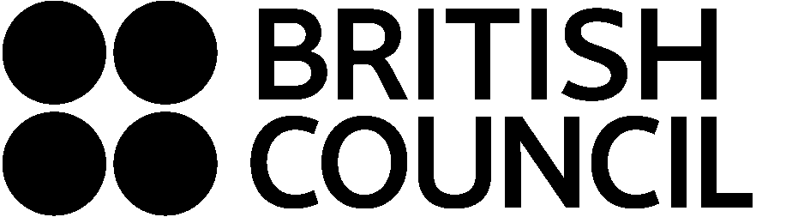

**Application Form for participating in**

**Literary Translation Workshop**

**13th to 17th October 2014**

**Karachi, Pakistan**

Literary translation workshops are an initiative of the British Council and Oxford University Press, in partnership with the British Centre for Literary Translation (BCLT). The week-long workshops will bring together writers and translators for intensive consensus translation, based on the BCLT International Literary Translation Summer School, held at the University of East Anglia since 2000.

Two parallel workshops will be held, on translating short stories from English to Urdu and Urdu to English with the respective authors in residence. Candidates can apply to be on one of the two workshops.

Applicants will demonstrate facility in Urdu and English by submitting a short sample of their translation work along with a completed application form.

Successful applicants will bear the costs of travel to Karachi and accommodation themselves or be sponsored by their institution/organization.

**Your details**:

Name

Gender

Nationality

Academic or professional qualifications

Occupation

Institute

Contact address

Telephone / Mobile

Email

Please give details of previous translation experience, including any published work.

Please tell us why you are interested in participating in this workshop and what you hope to get out of it.

**Please email your completed application form to** [**TranslationMasterclass@gmail.com**](mailto:TranslationMasterclass@gmail.com) **by 22 September 2014. Successful applicants will be notified by 26 September 2014.**

Thank you for your application.